Tasting at Château Lastours

A free-spirited, vibrant sensory experience at the heart of the Gaillac vineyards

Here at Château Lastours, tasting is above all a celebration. Freed from rigid codes, it’s inspired by a simple principle: *the best wine is the one you love*. There’s no need to be an expert to truly enjoy a wine — you simply have to let your senses guide you and savour the moment.

The Cradle of a Mosaic of Flavours

Planted in the heart of the Gaillac appellation, our estate carries over 2,000 years of winemaking history. Thanks to a rich diversity of indigenous grape varieties and time-honoured expertise, our cuvées express a wide range of complementary profiles: fresh, fruity whites; expressive reds; delicate rosés; and ancestral sparkling wines.

The Secret of Our Wines: Mastered Freshness

Alcoholic fermentation — the starting point of every winemaking process — is a living transformation where sugars become alcohol, releasing heat and gas in the process.

Our key innovation? Precise cold control at two pivotal stages:

* During harvest – carried out at night, when temperatures can drop by more than 20°C between day and night.
* During fermentation – a cold-water network precisely regulates temperature to preserve freshness and finesse.

Concrete or Stainless Steel: The Perfect Balance of Tradition and Technique

* Whites & Rosés – fermented in concrete tanks, naturally insulating to maintain freshness.
* Reds – fermented in stainless-steel tanks, ideal for controlling the heat produced during fermentation.

The Three Dimensions of Taste

* Primary – floral and fruity aromas, typical of each grape variety.
* Secondary – aromas developed during fermentation.
* Tertiary – complexity acquired through ageing and time in the bottle.

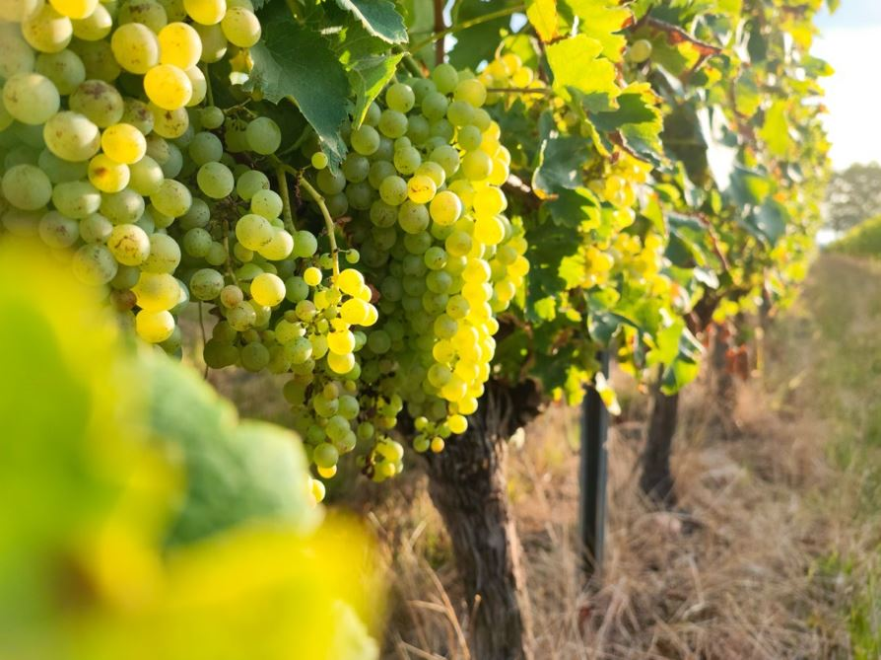

Our Cuvées to Discover

Sparkling Wines – The Ancestral Method

* Blanche Method – 100% Mauzac, crisp green apple aromas.
* Rosé Method – Gamay & Syrah, finesse with red fruit notes.

Still Whites

* Blanc Perlé – typically Gaillacois, with a delicate natural sparkle.
* Domeni Blanc – Mauzac, Loin de l’Œil, Muscadelle; fresh and fruity.
* Opus Blanc – Loin de l’Œil, Sauvignon; aged 9–10 months in oak barrels.
* Claire de Lune – buttery notes, 12 months in oak, a tribute to Claire de Faramond.
* Poussin Blanc – naturally sweet, low in alcohol, with gentle softness.

Rosés

* Domeni Rosé – cold-fermented, with a fruity palate and pale colour.
* Poussin Rosé – sweet, indulgent, low in alcohol, and convivial.
* Pétrichor Rosé – elegant and rounded, aged 10 months in barrel.

Reds

* Domeni Rouge – fruity, light, and easy to enjoy.
* Opus Rouge – barrel-aged, with structure and refined elegance.
* Pigeonnier – matured in new oak barrels; powerful and elegant, with spiced black fruit notes.
* Pétrichor – aged 2 years in 500L demi-muids; subtle woody hints enhancing ripe fruit.